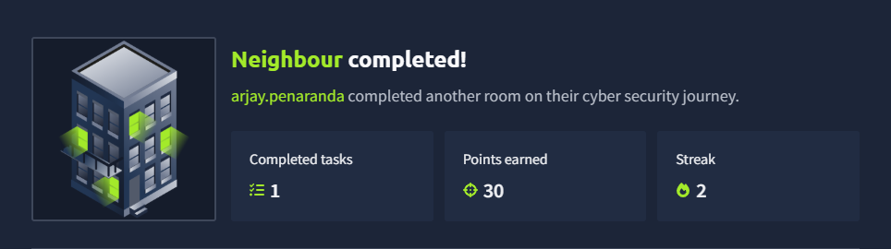

This is a classic TryHackMe room that focuses on Insecure Direct Object Reference (IDOR) vulnerabilities. It’s a great reminder that sometimes the most powerful "hacking" tool is just changing a single digit in your browser's address bar.

Phase 1: Reconnaissance
The first step is always to see what we’re dealing with. After deploying the machine and navigating to the provided IP address, you’re met with a simple login page.
- View Source: Right-click and "View Page Source" (). Often, developers leave hints or credentials in HTML comments.
- The Hint: In this specific room, a comment in the source code reveals a potential username or a "testing" account, which helps bypass the initial "who do I log in as?" hurdle.
Phase 2: Gaining Access
Using the hint found in the source code:
- Enter the username: guest (or the one found in the comments).
- Try common passwords or the one hinted at.
- Success: You are logged into a user dashboard.

Phase 3: Exploiting IDOR
This is the core of the room. Once logged in, look at the URL structure. You’ll notice a parameter that looks something like this:

http://<TARGET_IP>/profile.php?user=guest

The Logic
An IDOR vulnerability occurs when the application provides direct access to objects based on user-supplied input. If the server doesn't check if Guest is allowed to see Admin's data, we can simply swap the names.

The Attack
- Identify the parameter: user=guest.
- Change the value to admin: http://<TARGET_IP>/profile.php?user=admin.
- Press Enter.
- The flag will appear then

FLAG: flag{66be95c478473d91a5358f2440c7af1f}

